VERB PATTERNS
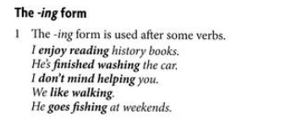
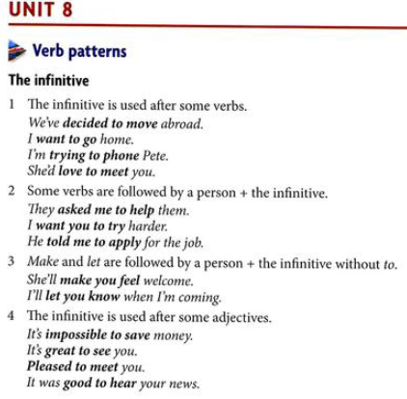
I’m lucky to have a house.
I’m delighted to see them.

Verb + sb + to + infinitive
warn
He warned me to go there.
!!! neg.
He warned me not to do that.

Verb + sb + infinitive (not to)
let
make
You made me go.

hope
manage

!!!
dare - can be without to
They don’t dare disagree.
help - can be without to
We helped clean up the kitchen.
adore
can’t stand
can’t help
don’t mind/ would you mind?
go + sports and activities
I go swimming.
give up
loathe
keen on
succeed in

I’m sorry for worrying you/hurting you/interrupting you.
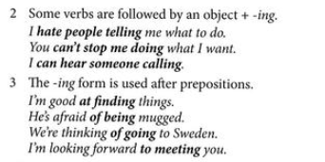

VERBS + -ing or to + infinitive

I remembered/forgot posting the letter.
(I have/don’t have a memory now - I did it). PAST
I remembered/forgot to post the letter.
(I remembered myself to post the letter - pripomínal som si, aby som nezabudol).
I NEED TO/NEEDED TO DO stg,

I stopped drinking coffee. (I don’t drink anymore). Action is no longer continuing.
I stopped to drink a coffee. (I stopped in order to have a coffee).

I tried counting sheep. (trying something as an experiment as a solution to a problem)
I tried turning the computer off and on.
I tried to count sheep. (something is difficult but you are making an effort to do it)
I’m trying to learn Japanese but it’s very difficult.

